# Technical Note

# Aggregations of Climate Projections Methodology

15 July 2025

# CMIP6 Downscaled Climate Projections for Aotearoa New Zealand

NIWA[1] has produced updated climate projections for Aotearoa New Zealand, by downscaling and bias-correcting models from the Coupled Model Intercomparison Project Phase Six (CMIP6)[2].

Two versions of those results have been provided to the Ministry for the Environment to make publicly available[3]:

* **The “Core Public Dataset” data**

More than 25 climate indicators, provided for two base periods, one historical and three future twenty-year periods, four warming levels, four scenarios, six models and multi-model mean (MMM), annual and (in most cases) four seasons, for values and change in values.

* **Daily data**

Daily bias-corrected data for 9 key variables for New Zealand, provided for the periods, warming levels, scenarios, models and seasons, as above.

Both sets of data are provided at Agent level, a gridded form described in the section on the NIWA VCSN grid below. This means values are provided for 11,491 grid-points. This complex data is provided in netCDF format[4] and the Ministry for the Environment is working to make data available in other formats for a wider range of users.

Many users and researchers need climate projections for particular areas, like a city, or town, for a district or region, for an area reported in the census, for iwi rohe, or for river catchments. This technical note describes how the data at grid-level is aggregated to areas that are meaningful to people.

# The NIWA VCSN Grid

The Virtual Climate Station Network (VCSN) is a grid developed by NIWA for historical climate data and for climate projections. The development of the VCSN historical data and transformation from observations to the gridded format is described in papers by Dr Andrew Tait and colleagues[5].

The VCSN grid has a resolution of approximately 5 km[6]. It has 11,491 gridded points or “agents” across New Zealand, excluding the Chatham Islands. The same grid is used for historical climate and the results of down-scaled climate model projections. The grid is illustrated as grey dots for part of North Canterbury in Figure 1.

**Figure 1: VCSN agents and spatial boundaries for Hurunui District and surrounding areas**

VSCN grid geospatial data sets are available on the [Climate Data Website](https://climatedata.environment.govt.nz/core-public-dataset.html#vcsn-agent-data)

# Spatial Amalgamations using the Lasso Method

A useful characteristic of evenly-spaced VCSN agents is that amalgamations can be done using spatial analysis techniques. In the simplest form, GIS[7] spatial analysis tools are used to “lasso”[8] and assign VCSN agents. Any polygon can be used to define a spatial amalgamation and extract the climate for that area.

The lasso method is conceptually straightforward. In Figure 1, the polygon for the Hurunui District Council is illustrated as a blue line. It is as if that blue line is a lasso thrown around the grid-points. The captured grid-points are then averaged to determine climate for the area.

The technique was explored initially for historical climate data by Professor Heather McLeod and Professor James Renwick in work done at Victoria University Wellington[9]. Spatial amalgamations produced using historical climate have included:

* **Island:** North Island, South Island.
* **Stats NZ** **administrative boundaries:** 15 regions, 67 territorial authorities, 2,175 SA2 areas[10].
* **Iwi rohe and areas of interest:** 107 iwi rohe, sourced from Te Puni Kōkiri.
* **Te Whatu Ora Health New Zealand areas:** fourregions and 18 districts for healthcare planning, as applicable in July 2022. Districts are amalgamated from District Health Board (DHB) definitions dated 2015.
* **Geographic Classification for Health (GCH)**: a classification of two urban and three rural categories, based on population size and drive-time to urban areas[11].
* **Department of Conservation (DOC) areas:** DOC Operations Districts and Regions; DOC National Parks, Reserves and Conservation Lands (>10,000 ha); and DOC Ecological Districts.
* **Kea Habitat**:an indicator from DOC of where kea may be present, based on New Zealand Bird Atlas data and other records.
* **Fire and Emergency NZ (FENZ) areas:** regions, climate zones, and grass-curing areas.
* **NIWA climate zones:** six zones[12], excluding the Chatham Islands. NIWA use these zones for regular reporting, a climate adaptation toolbox, and climate risk assessment[13].
* **Rainfall Response Areas:** 23 areas across New Zealand used for climate research.
* **Altitude groups:** six altitude groups, defined asBelow 160m, 160-300m, 300-600m, 600-900m, 900m-1200m, and Above 1200m. Derived from Toitū Te Whenua |Land Information New Zealand (LINZ) files of contours used in the 1:500k topographical series.

The technique works on any polygon that can be digitised and processed in GIS software. Effectively, the climate indicators for each spatial definition are the simple arithmetic average of the climate indicators for the “lassoed” agents.

The only limitation is whether the roughly 5km grid has enough points for meaningful climate. In Figure 1, the SA2 areas are also shown as light grey lines. In rural areas, an SA2 captures climate meaningfully, but in a city area like Christchurch, many SA2s are too small to capture any grid-point and so another technique is needed.

# Spatial Amalgamations to use with Socio-Economic Data

A problem arises when we want to determine climate for a small area, to link to vulnerability data for the same geographic area. The choice of the scale at which to link people and climate is informed by other studies in New Zealand, and the scale at which socio-economic data is readily available.

The **NZDep Index of Socioeconomic Deprivation** is produced by the University of Otago[14]. NZDep is an index of relative deprivation over successive waves of Census data from 1991 onwards[15]. Scores are produced for each meshblock, then amalgamated for SA1, SA2, and higher Stats NZ geographies[16]. NZDep is widely used in healthcare research and has applications for vulnerability for climate adaptation work.

Environmental Health Intelligence New Zealand (EHINZ) at Massey University developed the **EHINZ Social Vulnerability Indicators**. These were initially developed for flooding risk[17] and then extended to climate change[18]. The indicators were initially largely constructed using data from Census 2013 and NZDep2013, and later Census 2018 and NZDep2018, with SA2 areas as the base unit, and aggregations to higher geographies. EHINZ has released an updated set of indicators using Census 2023 and using a range of Stats NZ geographies[19].

The aggregations of the climate projections by the Ministry for the Environment are informed by the resolutions used for these measures of vulnerability and resilience to climate change. This means that climate and vulnerability can be compared at the same geographic resolution.

# Spatial Amalgamations using the Thiessen Method

The problem of climate for small areas was considered and resolved by McLeod and Renwick[20], and their peer-reviewed and published method has been adopted by the Ministry for the Environment.

When investigating ways of interpolating climate, the researchers used what are called Thiessen polygons[21]. These are constructed around each VCSN grid-point so that any location within the polygon is closer to that point than any other point. These Thiessen polygons were found to be a useful way to confirm regions of influence for grid-points in ArcGIS.

The NIWA VCSN grid is clipped to the coastline and the long coastline of New Zealand is a complicating factor. When Thiessen polygons are constructed around the 11,491 VCSN grid points it is found that 1,281 of the polygons (11.1%) have a join to the coast. This produces some long and complicated shapes that can stretch hundreds of kilometres offshore.

The Theissen polygons are illustrated for Gisborne in Figure 2 as grey lines around the grey dots of the VCSN grid. The complex geometry of Thiessen polygons along the coast means that only one of the four polygons has a conventional square grid form.

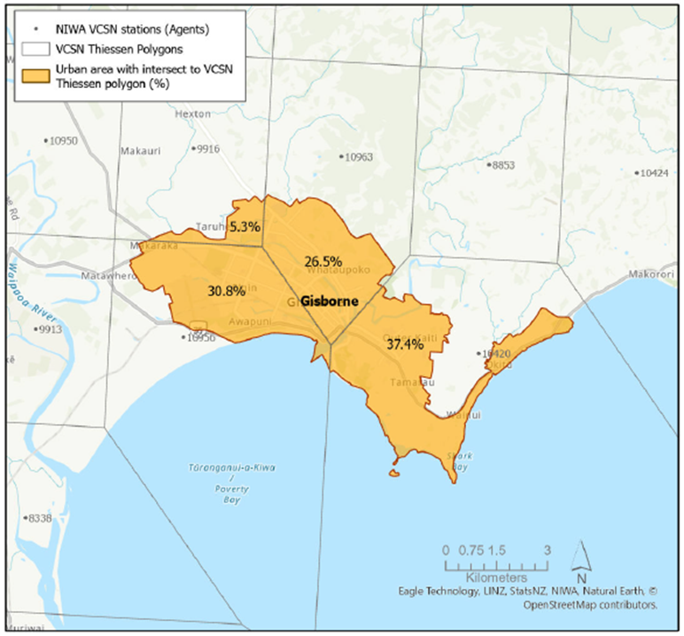

**Figure 2: Thiessen polygons and calculations for the Gisborne urban area**

The Gisborne urban area does not lasso any grid-points, but the Thiessen polygons clearly identify four grid-points that need to be in the solution. The Thiessen polygons are used to determine area weights: Thiessen polygons are drawn around each VCSN grid-point, with the weighting being the proportion of the urban area lying within each Thiessen polygon (the Thiessen pieces)[22]. The weighting for the lower right point for Gisborne thus becomes 37.4%. The total of the weights sums to one for any area.

An advantage of the Thiessen method is that the weights only need to be determined at the outset and can be used across all the climate variables and time periods[23]. While the technique was derived using historical data, the VCSN grid is also used for climate model projections and thus the same weights can be used for historical and projected results.

The weights need to be redone when the geography changes and the weights have been revised using the geographies produced by Stats NZ for Census 2023[24].

With the lasso method, the aggregation of climate is done using a straight mean. With the Thiessen method, the aggregation of the climate is done using a weighted mean[25]. Results of the lasso method and Thiessen method have been tested at SA2 level and aggregated levels (suburbs, urban areas, districts, and regions). The differences for larger areas are relatively small and, more importantly, the signal from the climate is almost identical for the two methods.

# Choice of Method for Stats NZ Geographies for the Climate Projections

The Thiessen methodology was initially considered as a solution for small urban areas, then expanded to be used directly on every SA2 area, regardless of size. In preparing a set of geographies to use with vulnerability data, the question arises as to which methodology should be used for which geography. There are clear answers at the largest scale (the lasso method is most intuitive) and the smallest scale (the lasso method is impossible, so the Thiessen method is used), but a line needs to be drawn somewhere in-between.

One argument is to use the Thiessen method all the time. It is argued that if the Thiessen method is essential for SA2 areas, then higher aggregations should be at the same geography. However, the VCSN grid is a latitude-longitude grid, and thus the curvature of the earth has an impact. The grid squares are much larger at the top of New Zealand than at the bottom, and so an area-weighted calculation for the whole of New Zealand shifts the climate towards the north. It is more intuitive to use the lasso approach for New Zealand as a whole.

A second consideration is that some geographies will always need to be done using lasso approach. For example, climate zones, river catchments and rainfall response areas are drawn with the topography, usually along the top of a ridge. It makes no sense to bring in grid-points from outside that geography, no matter how small the effect.

For the initial release of aggregated climate data, the focus is on the use of Stats NZ geographies. Stats NZ uses a hierarchy of geographies, building off meshblocks as the base unit. The pathways of amalgamation of meshblocks differ between statistical geography (the form in which statistics are released), electoral geography (areas designated for voting), administrative geographies (like District Councils) and for healthcare districts. Figure 3 illustrates the 2023 geographies[26].

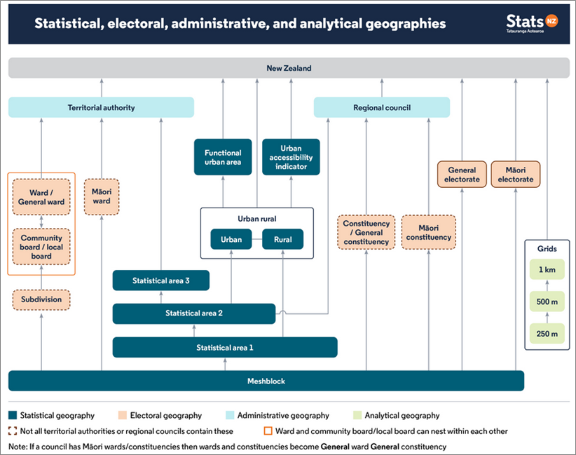

**Figure 3: Stats NZ Geographies 2023**

Meshblocks (60-120 people) are the smallest unit in the census, but the data is typically only available to researchers under tightly controlled conditions. Statistical area 1s (SA1s) are the physical equivalent of a city or rural block (100-200 people). Statistical area 2s (SA2s) amalgamate SA1s into recognisable suburbs or rural communities (1,000-4,000 people) and are widely used in the release of Census 2023.

Territorial authorities (TAs) and regional councils are separate amalgamations of SA2 areas. For Census 2023, Statistical area 3s (SA3s) are added to represent suburbs in larger urban areas and minimise data suppression. All these statistical geographies are helpful for linking to Census data and hence to measures of vulnerability and resilience to climate change.

Health Regions are very large and the largest is Te Waipounamu (South Island). This needs to be identical to the South Island climate, and hence Health Regions use the lasso method used for New Zealand and Island. Health Districts are typically large and thus use the same methodology. All other Stats NZ geographies use the Thiessen approach, to provide continuity from SA2 level upward.

In summary, the geographic aggregations of the NIWA “Core” climate projections and the methodology used are as follows:

|  |  |  |
| --- | --- | --- |
| **Geography**  **Abbreviation** | **Geography Explanation** | **Method** |
| New Zealand | All of New Zealand | Lasso |
| Island | North/ South Island | Lasso |
| Region | Regional Council 2023 | Thiessen |
| TA | Territorial Authority 2023 | Thiessen |
| TALB | Territorial Authority and Local Boards | Thiessen |
| SA3 | Statistical Area 3 2023 | Thiessen |
| SA2 | Statistical Area 2 2023 | Thiessen |
| Urban | Cities, towns, and rural settlements from Urban Rural 2023 | Thiessen |
| Health Region | Health NZ Te Whatu Ora Health Regions | Lasso |
| Health District | Health NZ Te Whatu Ora Health Districts | Lasso |

Further amalgamations of climate projections at geographies useful for environmental monitoring may be added later.

|  |  |  |
| --- | --- | --- |
| **Data and Insights Products** |  |  |
| **Ministry for the Environment | Manatū Mō Te Taiao** | | |
| For queries, contact: | [ClimateData@mfe.govt.nz](mailto:ClimateData@mfe.govt.nz%20) | |
| *Last update 15 July 2025* |  |  |

1. NIWA is the National Institute of Water and Atmospheric Research, a Crown Research Institute. As of 1 July 2025, NIWA and GNS Science have been merged into a new entity, Earth Sciences New Zealand.
2. User Guidance of CMIP6 Downscaled Data for Aotearoa New Zealand.

   <https://climatedata.environment.govt.nz/files/CMIP6_guidance_doc_June2024.pdf>
3. NIWA makes additional raw data available directly.

   <https://niwa.co.nz/climate-and-weather/updated-national-climate-projections-new-zealand>
4. NetCDF format: <https://www.unidata.ucar.edu/software/netcdf/>
5. See for example:

   Tait, A., & Macara, G. (2014). Evaluation of interpolated daily temperature data for high elevation areas in New Zealand. *Weather and Climate, 34*, 36-49. <http://www.jstor.org/stable/26169743>

   Tait, A., Sturman, J., & Clark, M. (2012). An assessment of the accuracy of interpolated daily rainfall for New Zealand. *Journal of Hydrology (New Zealand), 51*(1), 25-44. <http://www.jstor.org.helicon.vuw.ac.nz/stable/43944886>
6. Technically, results are produced for a 0.05° latitude/longitude grid covering all New Zealand, excluding the offshore islands, which gives a resolution of approximately 5km. The VCSN grid has an average of 4.2 km in latitude and 5.5 km in longitude, giving grid cells of 23 km2. This is an average resolution of 4.8km, but is usually described as ”approximately 5km”. With the curvature of the earth, the grid cells are larger in the north than the south of New Zealand.
7. Geographic Information System (GIS). The work described here is done in ArcGIS, from ESRI.

   <https://www.esri.com/en-us/arcgis/geospatial-platform/overview>
8. The “lasso method” is a descriptive name for the process and is not the same as the statistical and machine learning regression technique known as lasso (least absolute shrinkage and selection operator).
9. McLeod, H., & Renwick, J. (2024). Linking People and Climate: The Extreme Events Climate Index for Aotearoa for Stats NZ geographies and iwi rohe. *New Zealand Population Review, 50*, 269-324. <https://population.org.nz/wp-content/uploads/2024/10/NZPR-VOL-50_McLeod-and-Renwick.pdf>
10. Statistical area 2s (SA2) are recognisable suburbs or rural communities with 1,000 to 4,000 people. Territorial authorities (TA) are districts. TAs and regional councils are separate amalgamations of SA2 areas.
11. Whitehead, J., Davie, G., de Graaf, B., Crengle, S., Fearnley, D., Smith, M., . . . Nixon, G. (2022). Defining rural in Aotearoa New Zealand: a novel geographic classification for health purposes. *N Z Med J, 135*(1559), 24-40. <https://www.ncbi.nlm.nih.gov/pubmed/35999779>
12. The origin of the NIWA climate zone schema is attributed to Kidson & Renwick (2002), drawing on earlier analysis by Mullan (1998).
13. Ministry for the Environment. (2019). *Arotakenga Huringa Āhuarangi: A Framework for the National Climate Change Risk Assessment for Aotearoa New Zealand*. <https://environment.govt.nz/publications/arotakenga-huringa-ahuarangi-a-framework-for-the-national-climate-change-risk-assessment-for-aotearoa-new-zealand/>
14. <https://www.otago.ac.nz/wellington/research/groups/research-groups-in-the-department-of-public-health/hirp/socioeconomic-deprivation-indexes-nzdep-and-nzidep-department-of-public-health>
15. The following tables have been produced: NZDep91, NZDep96, NZDep2001, NZDep2006, NZDep2013, NZDep2018, and NZDep2023. Census 2023 was used to construct NZDep2023.
16. NZDep2023 Index of Socioeconomic Deprivation: Research Report. [https://www.otago.ac.nz/ __data/assets/pdf_file/0026/593135/NZDep2023-Research-Report-31-October-2024.pdf](https://www.otago.ac.nz/%20__data/assets/pdf_file/0026/593135/NZDep2023-Research-Report-31-October-2024.pdf)
17. Mason, K., Lindberg, K., Haenfling, C., Schori, A., Marsters, H., Read, D., & Borman, B. (2021). Social Vulnerability Indicators for Flooding in Aotearoa New Zealand. *International Journal of Environmental Research and Public Health, 18*(8), 3952. <https://www.mdpi.com/1660-4601/18/8/3952>
18. Social vulnerability to the impacts of climate-related hazards in Aotearoa New Zealand

    <https://www.climatecommission.govt.nz/assets/Monitoring-and-reporting/NAPPA-2024/3.a-EHINZ_Social-vulnerability-to-the-impacts-of-climate-related-hazards.pdf>
19. Social vulnerability indicators for 2023

    <https://www.ehinz.ac.nz/social-vulnerability/social-vulnerability-indicators-for-2023/>
20. McLeod, H., & Renwick, J. (2024). Linking People and Climate: The Extreme Events Climate Index for Aotearoa for Stats NZ geographies and iwi rohe. *New Zealand Population Review, 50*, 269-324. <https://population.org.nz/wp-content/uploads/2024/10/NZPR-VOL-50_McLeod-and-Renwick.pdf>
21. In some fields these are known as Voronoi polygons, or as Voronoi diagrams or Voronoi tessellation.
22. The process is described for the 2022 geography for SA2 areas. Thiessen polygons are drawn in ArcGIS around the 11,491 VCSN agents. A pairwise intersection of the Thiessen polygons with the 2,175 SA2 areas effectively cuts each SA2 into component pieces, with each piece having an identified agent. The list of 11,491 agents expands to 20,584 SA2-agent combinations. The area of the initial SA2 is determined (SA2_TotalArea) and the area of the SA2 Thiessen piece is obtained in the intersection (SHAPE_Area). The weighting for each SA2-agent piece is calculated as: SA2_Weight= SHAPE_Area/ SA2_TotalArea.
23. In contrast, interpolation techniques would require interpolation of every variable, for every time period.
24. Stats NZ. (2022). Statistical standard for geographic areas 2023. <https://www.stats.govt.nz/methods/statistical-standard-for-geographic-areas-2023/>
25. The list of 20,584 SA2-agent combinations is indexed, then used to expand the results file with multiple copies for agents that are used more than once. This expands the dataset temporarily from 11,491 blocks of results to 20,584 blocks of results. A weighted collapse of the layers, using the weights derived above, reduces the results to 2,175 blocks of results, one block for each SA2 area. The collapse of the weights is checked to ensure that the total is equal to one for each SA2.
26. Stats NZ geographies can be visualised on the Geographic Boundary Viewer:

    <https://www.stats.govt.nz/geographic-boundary-viewer/>